**TRENDS IN FIRST CLASS CRICKET IN NEW ZEALAND**

**FROM** **1907/08**

**INTRODUCTION**

This analysis was first prepared in 1991 when at that time there was a great deal of discussion over the merits or otherwise of four day cricket and whether its re-introduction to the domestic competition would be of benefit to New Zealand cricket.

The two main reasons given in advocating change were:

that it would make the adjustment from first class cricket to test cricket easier for the players

that competition for the Shell Trophy would be a fairer indication of the standards of the teams as the extra playing hours would reduce the number of declarations required to produce outright decisions.

It was therefore decided to analyze the first class cricket competition, the Plunket Shield, from 1945/46 in the expectation that certain trends would emerge which might help in the debate and any decisions to be made.

The statistics were updated in April 2018 to include the period from 1907/08 to 1939/40. The five years from 1940/41 to 1944/45 have not been included as there was no competition for the Plunket Shield competition due to the Second World War.

At the conclusion of the 1906/07 season, the New Zealand Cricket Council awarded the Plunket Shield to Canterbury based on their performances that year. The following season Auckland made the first challenge and in a three day match defeated Canterbury by an innings and135 runs.

All three provinces made a challenge in the 1909/10 season and from then on until the 1914/15 season there were three to four challenge matches played each year. Due to the advent of the First World War there was no first class cricket played in the three year period from 1915/16. The competition for the Plunket Shield began again in the 1918/19 season but there had been concern for some time that the challenge system was not ideal. After consultation with the four major associations the New Zealand Cricket Council decide on a league competition where all associations would play each other and the Shield would be awarded on the number of matches won.

**HISTORY**

**1.Duration of Games**

From the 1907/08 season many matches were often classified as unlimited, some were

Listed to be of four days duration but the majority were completed within three days. From 1927/28 to 1939/40 matches were played over four days, but again many were finished within three days. After the 2nd World War had ended the Plunket Shield competition began in the 1945/46 season and matches were continued over the four days duration.

Nine years later in the 1954/55 season the change was made back to three day matches, a decision that had been preceded by much debate highlighted by Arthur Carman's comments in the 1952/53 Almanack when "he felt certain that a great deal of the negative and aimless batting and bowling which is too often witnessed at present is due to the idea that there is too much time available. With a three day limit more attractive play would almost certainly result, necessarily so if a bid was made for victory."

Four day cricket was played over 24 hours, ie 6 hours/day, but at the time of the change to three day cricket the playing hours were extended by half an hour each day, so that in effect the total time available was 19 1/2 hours. Those hours remained in force until the 1966/67 season when by beginning games at 10am, a seven hour playing day was established, 21 hours total time.

The reintroduction of four day cricket in 1992/93 initially maintained the 7 hour playing day, 28 hours in total, but the following season 1993/94, saw a reduction in daily playing time to 6 1/2 hours/day or 26 hours total time but could be longer if the required number of overs had not been achieved.

In effect the move to four day cricket from 1993/94 created an extra five hours of play with a minimum extra 64 overs of play. Over the period from 1907/08 until 2017/18 there were 103 seasons of Plunket Shield cricket with 49 seasons of four day cricket and 54 seasons of three day cricket.

**2. Provinces**

Central Districts were introduced to first class cricket in 1950/51 and were followed by Northern Districts in the 1956/57 season.

**3. Points**

**1907/08 to 1914/15**: Challenge system. No points.

**1918/19 to 1929/20**: Outright wins one point and if a tie in victories achieved, the Plunket Shield decided on the best net runs per wicket.

**1930/31 to 1957/58** : outright decisions **8** points, a 1st innings win **4** points and a 1st innings loss **2** points

**1958/59 to 1969/70** : outright decisions**10** points, a 1st innings win **5** point; a 1st innings loss **1** point, **3** points for a 1st innings lead when beaten outright.

**1970/71 to 1981/82**: bonus points introduced for 1st innings, but outrights points remained at 10. Over this 12 period a number of modifications were made to the bonus points system before their final elimination at the end of the 1981/82 season.

**1982/83 to 1993/94**: outright decisions **12** plus an extra **4** points for leading on the 1st innings. No points for a 1st innings loss.

**1994/95 to 1996/97:** outright decisions **8** points plus an extra **4** points for a 1st innings win. No points for a 1st innings loss.

**1997/98 to 2002/03**: outright decisions **6** points, 1st innings lead **2** points if team did not win outright or match drawn. No points for a 1st innings loss.

**2003/04 to 2010/11**: a change was made to allow a maximum of **8** points if an outright and 1st innings points were achieved. 2 points for a 1st innings win but an outright loss.

**2011/12 to 2017/18**: Bonus points were introduced. 12 points for an outright win, 6 points for a tie. No points for a first innings win or loss. Also available were batting points at 250, 300, 350 and 400 runs and bowling points at 3, 5, 7, and 9 wickets for the first 110 overs of the first innings.

**4. Overs**.

Six balls overs have been used for all years except for a period of eight years from 1918/19 until 1926/27, five years

from 1937/38 until 1943/44 and 11 years from 1968/69 to 1978/79 when 8 ball overs were tried. ie of the 106 seasons up to

2017/18 eight ball overs were used for 24 seasons.

A limitation on the number of overs to be bowled in the 1st innings was introduced for six years from 1976/77 to 1981/82 inclusive. The first three years **there were 75 8 ball** overs and the last three years there were **100 6 ball** overs limited.

Penalty points for slow over rates were introduced in 1979/80 and various formats tried for 7 years. Initially a rate of

**18 overs/hour** over the entire course of the **match** was required but after one year the requirement was reduced to **17 overs/ hour**.

In 1983/84 the requirement was changed to be applied over the course of the whole **season,** but after a further 3 years

under this system the concept of penalty points applying to slow over rates was abolished at the conclusion of the 1985/86 season.

For 3 years from 1986/87 to 1988/89 there was a requirement for a minimum of **119 overs** to be bowled in a day’s play,

but with many games continuing 45 to 60 minutes beyond the scheduled close of play, this rule had no effect on maintaining

a reasonable over rate.

In 1989/90 in an endeavour to overcome this problem, the minimum daily rate was reduced to **112 overs** but an additional

requirement of bowling **17 overs/hour** **over the course of a** **match** was also introduced. Over rate point penalties were also

reintroduced. However after 1 year the regulation was again changed with the new rate being **17 overs/hour over the season**.

In 1993/94 an additional over rate penalty of $1,000 was introduced for each over under 17 per hour.

From 1998/99 to 2009/10 the minimum daily rate was reduced to **100 overs** (15 overs per hour) but with no reduction

for change of innings, fall of wickets or first drinks interval in any session. Penalties for slow over rates were now only financial

and were calculated round by round rather than over the whole season.

Below 15 overs per hour but not below 14. $1,000.00

Below 14 overs per hour. $2,000.00

In 2010/11 the only change was to require **100 overs** to be bowled in a day but with no reduction for a change of innings.

In 2011/12 the only change was to require **97 overs** to be bowled in a day. Penalties for slow over rates were unchanged.

From 2015/16 to 2017/18 a change was made to require **96 overs** to be bowled in a day. Penalties for slow over rates were unchanged

**5. Number of Games**.

A new sponsorship by the Shell Oil Company in **1975/76** saw an increase in the number of rounds each season from

5 to 7 with the Grand Final concept tried for the first three years. An increase to an 8 round competition began in **1982/83**

with an extension to 10 rounds introduced in **1989/90.**

In **1992/93** four day cricket was introduced in a limited manner, the 1st round of 5 matches was played over three days followed

by a 2nd round of 3 matches played over four days and then a final.

In **1993/94** one round of 5 matches was played over four days followed by 2 semi-finals and a final.

In **1994/95** 7 rounds of four day matches were played followed by a final.

In **1995/96** 5 rounds of four day matches were played followed by a final.

In **1996/97** 8 rounds of four day matches were played followed by a final.

In **1997/98** to **1999/00** 5 rounds of four day matches were played followed by a final with the final in 1998/99 and 1999/00

being played over 5 days.

In **2000/01, 2001/02, 2002/03** 10 rounds of four day matches were played with no final.

In **2003/04** 8 rounds of four day matches were played with a final played over four days.

In **2004/05 to 2008/09** the final was played over five days with the number of overs in a day set at 90. The top qualifier

hosted the final (except in 2008/09 when it was played at Lincoln), and the second placed team had to win outright to take

the title.

From **2009/10 to 2017/18** the competition was extended to 10 rounds with no final played

**RESULTS 1ST CLASS CRICKET**

1. Note that the blue/black line in the graphs indicate the period of three day cricket, the black/red lines four day cricket.

2. Innings are only counted if they last longer than 10 overs.

**Graph 1**

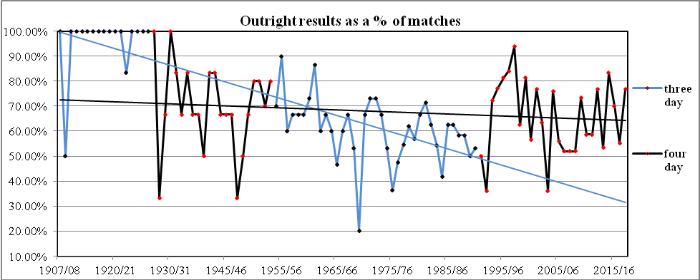

This graph analyses the number of outrights achievedas a percentage of matches played in each year. In the first twenty

years from the 1907/08 season there were only two seasons when no outrights decisions occurred. Over the next period

until 1992/93 there was clearly a steady decline in outright results which was a major reason for the push for four day

cricket.

The introduction showed an initial rapid increase in the number of outrights to reach a peak of 94% in the

1997/98 season. This result was affected to some extent by a wet season where there were a number of contrived results.

In contrast the poor weather of 1998/99 saw more declarations but fewer outrights, in fact a number of matches did not

even achieve a first innings result.

Over the 49 seasons of four day cricket only 13 years have seen more than 70% of matches ending in an outright

decision and the overall average is 65%. This is only slightly higher than the average of 60% of outrights over the 54 years

of three day cricket.

**Graph 2.**

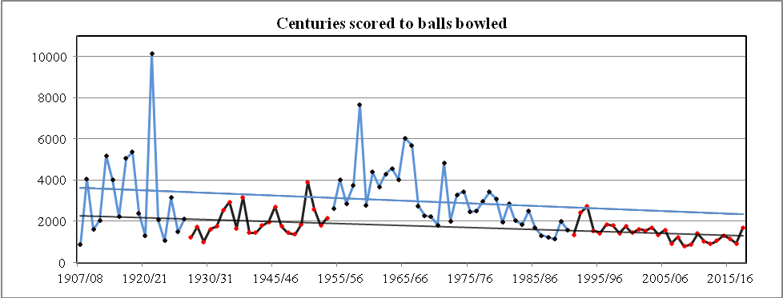

This graph analyses the number of centuries scored to the total number of balls bowled each year. In the first twelve years

few centuries were scored but from 1922/23 they became more frequent with 13 scored in the 1923/24 season. The ratio was

reasonably static over the next thirty years until the reintroduction of three day cricket in 1954/55 saw the number of

centuries reduce quite substantially. However this trend changed around the early 1980’s and the number of centuries has

increased since then to hover around a century for every 1000 balls bowled.

The highest ratio was achieved in 2008/09 when 62 centuries were scored at the new figure of 791 balls bowled.

The following season 66 centuries were scored at a slightly higher ratio but in 2017/18 only 29 centuries were scored at the

worst ratio since 2003/04.

**Graph 3.**

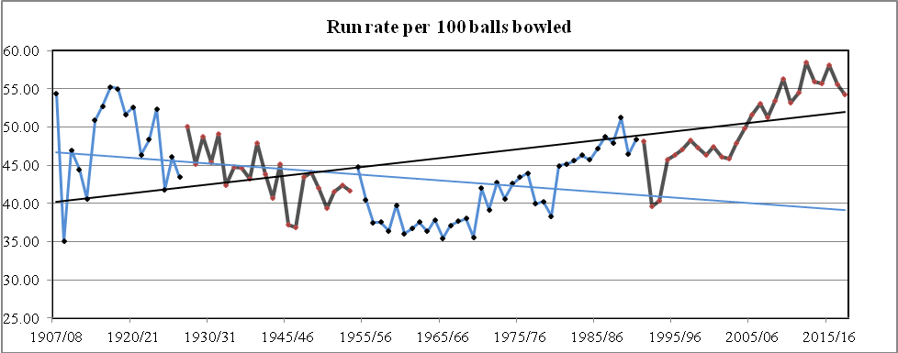

This graph indicates the rate at which runs have been scored per 100 balls bowled and the difference between matches

Played over four days and three days. Normally the run rate is shown in runs per over but due to the 24 year period when

eight ball overs were in play the 100 ball rate is used in this graph.

In eleven of the first sixteen years the run rate was over 50 equivalent to 3 runs per six ball overs. From 1920/21 the

rate falls until it reaches its lowest rate in 1969/70 at 35. Since that time there has been gradual increase with the rate really

taking off with the introduction of the Shell Cup competition in 1980/81. The 1988/89 season produced a very high rate when

it exceeded 50 runs/100 balls for the first time since 1927/28.

Surprisingly the first two years of 4 day cricket in 1992/93 and 1993/94 saw a slowing of the run rate. However since

then the rate has increased and from the 2005/06 season the rate has never gone below 50 runs/100 balls with the highest

rate reached in 2012/13 at 58 equivalent to 3.5 runs per over. 2015/16 season was also high at 58 but the last two seasons

have seen a slight fall to 55 and 54 respectively.

**Graph 4**

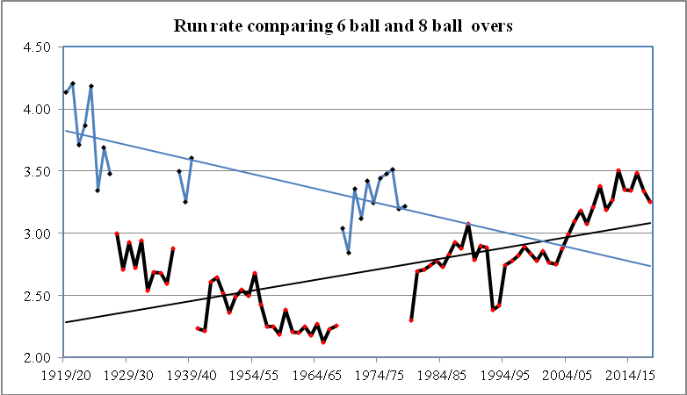

This graph shows the difference between the run rate for six and eight ball overs. In the three periods of eight ball overs

the run rate is over three in 21 of the 22 years but noticeably dropping over time. Over the six ball over period

the rate never reaches three runs until the 1988/89 season. It then drops again to reach a low in 1992/93 before it increases

rapidly to reach a high of 3.51 in the 2012/13 season.

**Graph 5.**

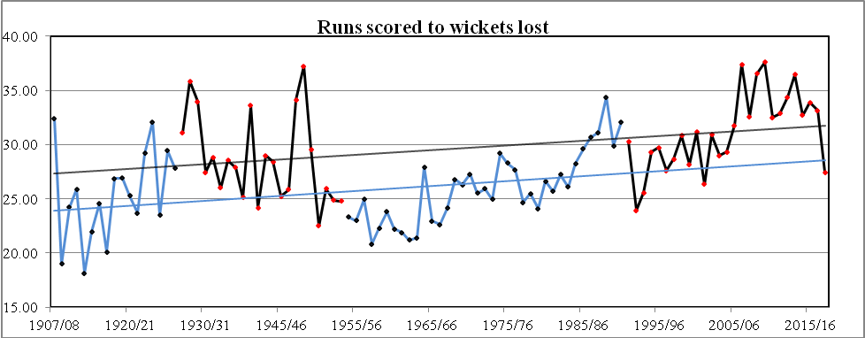

This graph analyses the number of runs scored for every wicket taken. The initial period from 1907/08 shows a ratio

well under 25 runs for every wicket to fall. Over the period from 1928/29 the ratio stayed for most of the time between

25 and 30 until the 1950/51 season when the rate fell below 25 and remained at that low figure for most of the next

30 years. The increase began in the early 1980’s but it was not until 2006/07 when it jumped to 37 runs that there was

any great change. The low figure for the 2017/18 season at 27.44 was in line with most of the other low statistics for that year.

**Graph 6.**

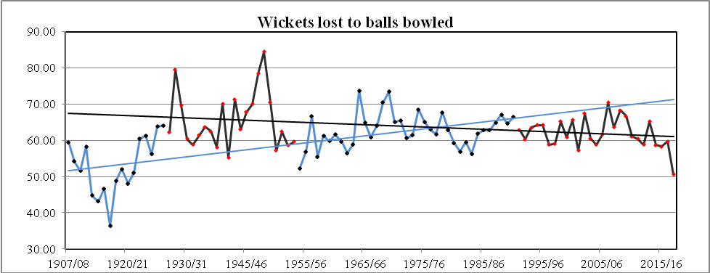

This graph analyses the number of balls bowled for every wicket taken. In the first 12 years a wicket was taken on average

at every 50 balls but the introduction of four day cricket saw the rate rise to reach a high of 84 in 1948/49, a wicket

every 14 overs. With the change to three day cricket the rate dropped slightly to a 65 average and continued when four day

cricket was reintroduced in 1991/92. Over the past 27 seasons of four day cricket the rate has fluctuated between 57 and

70 balls per wicket with only six seasons with a rate above 65 balls. In general the trend over the period of four day cricket

has seen wickets fall more frequently. The 2017/18 season saw a dramatic change to a rate of 50, a figure not seen since 1920/21.

**Graph 7.**

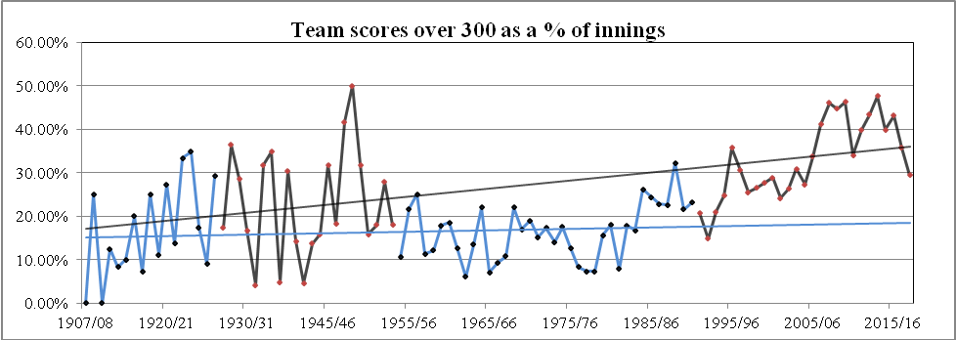

This graph shows the number of team scores over 300 as a percentage of innings played. Over the first 32 years there was

much variation from a high of 36% in 1928/29 to below10% in ten of the seasons. The early period of four day cricket

shows that there were a number of high scores with a high of 50% of innings in 1948/49. This was followed by a rapid

drop to the low of 6% in 1962/63. The six year period from 1976/77, when there was a limit of basically 600 balls allowed

to be bowled in the first innings, saw the percentage fall below 10%. Since that time scores over 300 have risen and over

the last twelve years, nine seasons have seen 40% or more innings reach that figure. The 2017/18 season drop to 30%

follows the trend for that year.

**Graph 7.**

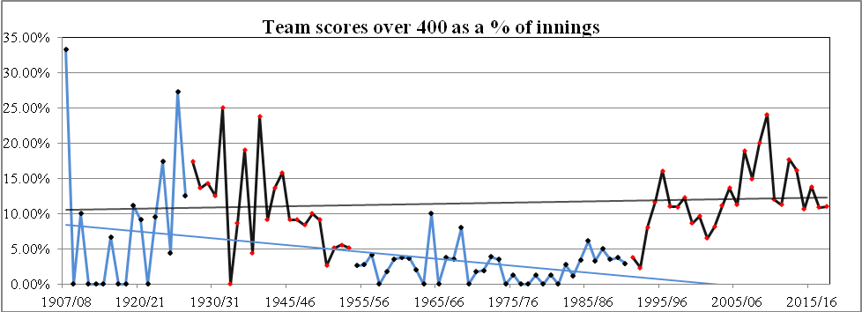

This graph shows that initially there were very few scores over 400 until the 1925/26 season when the percentage reached

28 and remained high until the 1936/37 season. From then on the percentage dropped considerably through the 60’s, 70’s

and 80’s and it was not until 1994/95 that the percentage of 15% was reached. However in general the move to four day

cricket has seen the rate rise, more particularly after the 2005/06 season and it reached a high of 24% in 2009/10. Of interest

to note that the high number of scores over 300 in 2013/14 did not translate to a higher number of scores over 400, only 16%.

**Graph 8**

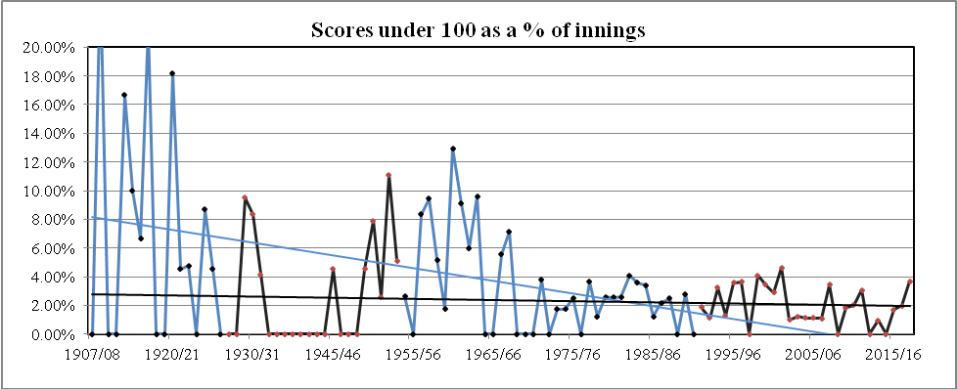

This graph shows the percentage of team scores under 100. In the period from 1907/08 until 1972/73, 61 seasons, there

was a marked variation from the high of 20% in 1908/09 to 28 seasons when no low scores were registered. Since that

time the trend has remained on a downward line with an average of just over one score under 100 each season over the

last 27 years. The one anomaly was in 2001/02 when five scores were registered under 100, 4.63%.

**Graph 9**

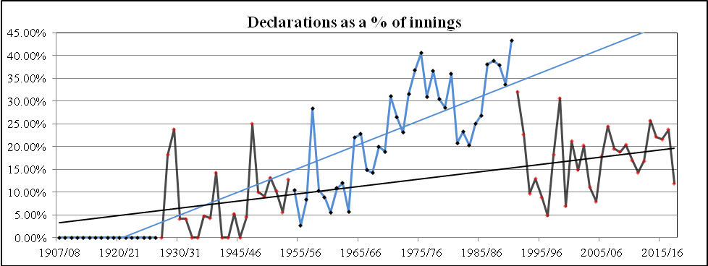

This graph shows the number of declarations as a percentage of innings. In the first twenty years declarations were not needed

as most matches were timeless and most finished within three days. From the 1945/46 season there was generally little change

until 1964/65 when a gradual increase in the number of declarations began. The six year period from 1976/77 saw a limitation

of overs on the first innings to gain bonus points and this had an effect on when declarations were made.

From the 1991/92 season there was a reduction in declarations, particularly with the advent of four day cricket.

The last 13 years of four day cricket shows an average of 20% of innings having a declaration compared to 31% for the last

13 years of three day cricket. ie 358 declarations to 258 declarations.

Over the four of the past five seasons the percentage has stabilized around 21% of innings but the trend shows over the

period of four day cricket a slight increase aligned with the greater number of innings over 400 a contributing factor

**Graph 10**

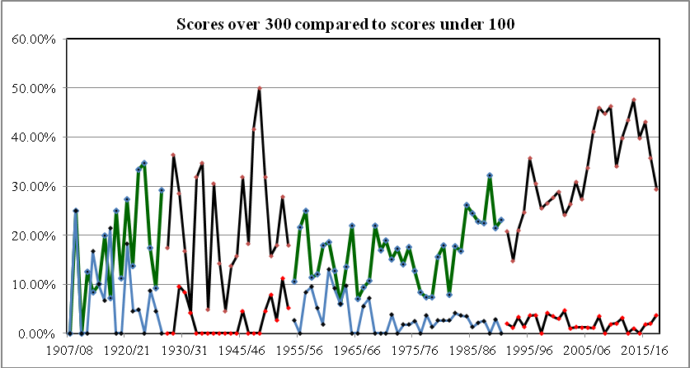

This graph compares team scores in excess of 300 and less than 100 as a percentage of total innings. In the early years the percentage gap between the two remained constantly below 10% with the worst season in 1962/63 where there were identical

scores, only three scores over 300 and three under 100. It was not until the introduction four day cricket that the gap widen appreciably. The greatest difference came in the 2013/14 season at 47% with 50 scores over 30 and only one score under

100. The 2018/19 season reversed the trend with only 32 scores over 300 and a high of four scores under 100.

**Graph 11.**

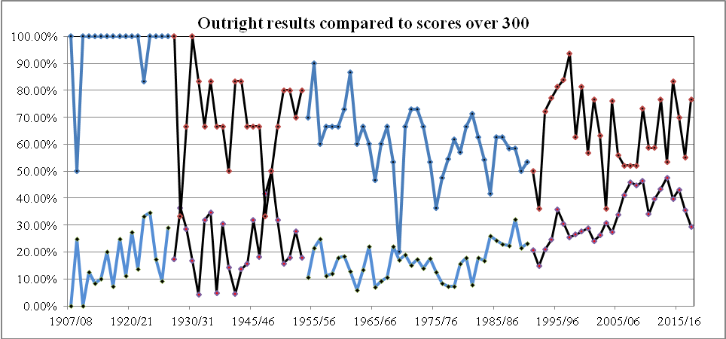

This graph looks at the relationship between outrights achieved and team scores over 300. Outright decisions are in upper line.

Not surprisingly the closer the two lines merge it indicates that more frequent scores over 300 reduce the number ofoutright

results. The 1961/2 season shows the largest difference with outrights occurring in 87% of games and scores over 300 low at 14%. However from 2003/04 there is a noticeable change with the increase in 300 plus scores reducing the number of results.

The 2013/14 season saw a low difference at 6%. 53 % of matches had an outright decision whilst scores over 300 were at 47%.

**Graph 12.**

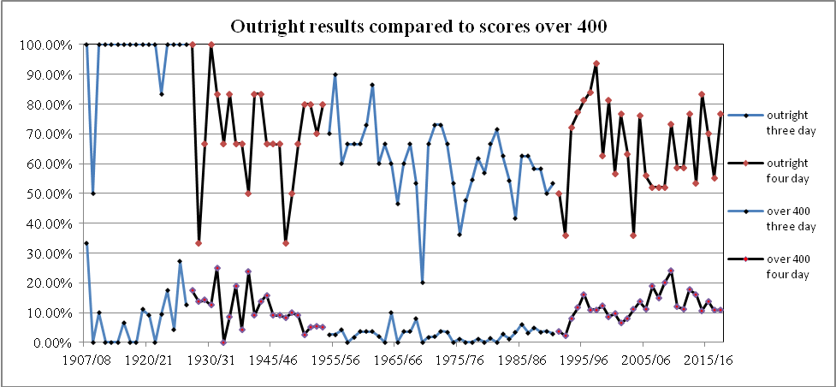

This graph looks at the relationship between outrights achieved and team scores over 400. Compared with graph 11, not

surprisingly, the greater number of scores over 400 reduces the number of outrights results. The 1955/56 season shows the largest difference with outrights occurring in 90% of games and scores over 400 low at 3%. The 1997/98 season also had a high

with 93% of matches resulting in an outright decision whilst scores over 400 were at 11%. The 1969/70 season was unusual

in that only 20% of matches had a decision and there were no scores over 400.

**Graph 13.**

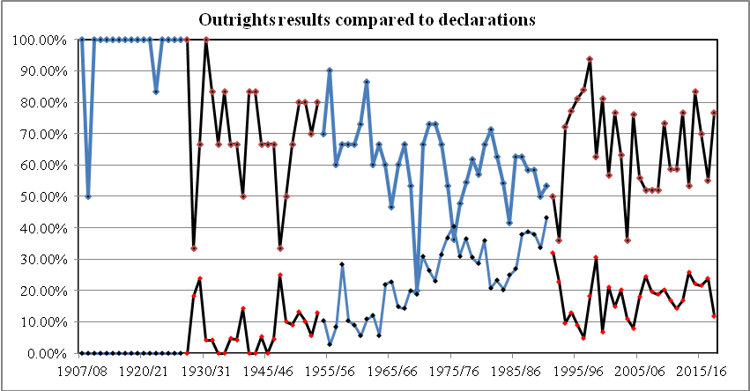

This graph compares the effect of declarations on achieving outright decisions. In the early period very few declarations were required to achieve outright decisions. However this totally changed during the period between 1970 and 1992 when the high

number of declarations produced fewer results, the standout season being 1969/70 when there were only three outrights in 15 matches and 10 declarations in 50 innings. ie. 20% of results and 18% of declarations. The second period of four day matches

saw the number of results increase with a reduced number of declarations. In 1999/00 81% of outrights and 7% of declarations produced one of the largest differences followed by the 2004/05 season which had a difference of 66%. Since then the ratio has

been static averaging around the 50% mark.

**Graph 14.**

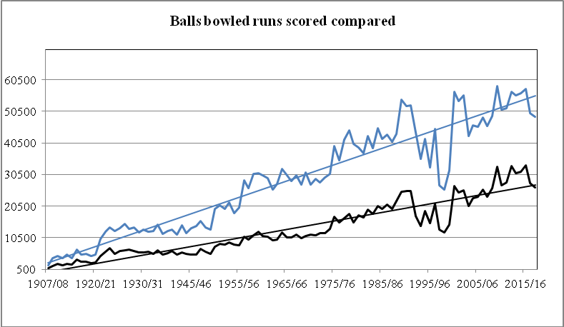

This graphshows how there was a reduction in runs scored and balls bowled after the introduction of 4 day cricket

in 1992/93 and it was only with the introduction of two rounds of four day cricket in 2000/01 that increased the

opportunity for more first class cricket. The reduction to eight rounds of four day cricket from 2003/04 to 2007/08

saw the total numbers align to that of the last period of three day cricket. The trend over the 103 seasons shows that

there has been an increase in the runs to balls ratio from very little difference to the largest in 2009/10 when there

were 58,570 balls bowled to 33,016 runs scored.

**Graph 15**

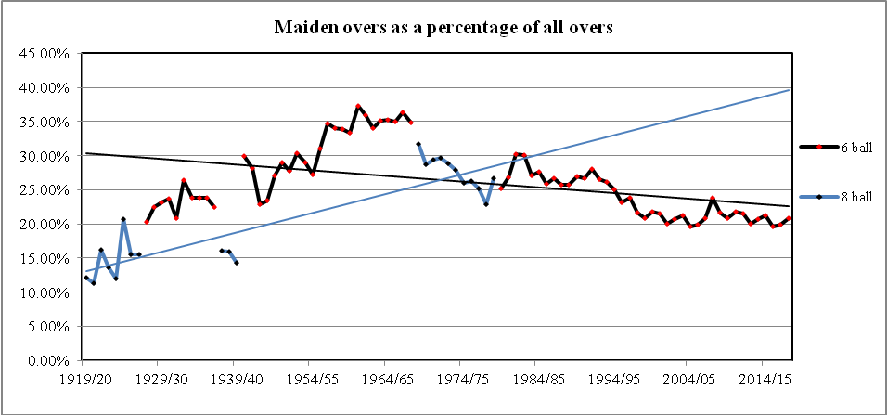

This graph shows the relationship between maiden overs bowled to all overs bowled. From 1919/20 maiden overs

increased during both the eight ball and six ball overs period. The highest percentage of maiden overs came in the 1960/61

season when 37% of the overs bowled were maidens. Over the later period of six ball overs maiden overs have declined

and more particularly with the introduction of four day cricket matches in 1991/92. The lowest percentage during the four day

cricket period came in 2015/16 when 19.5% of overs were maidens.

**Graph 16.**

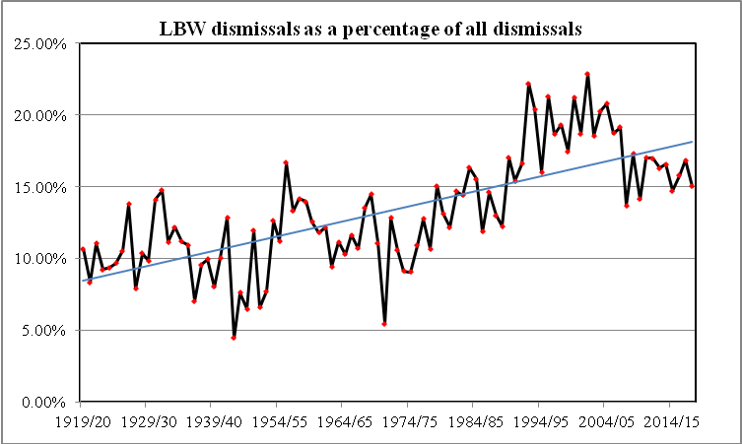

This graph shows the percentage of lbw dismissals from 1919/20. The lbw decision is the most controversial decision

in cricket, first appearing in laws of 1774. The initial law was formed when batsmen began using their pads to protect

the stumps and it specifically noted that the legs were involved and the ball had to be pitched in line with the wickets.

Later the law was changed to mean any part of the body.

In 1937, in a response to an increasing amount of pad play, the law was changed to enable a batsman to be dismissed

even if the ball landed outside the line of the off stump but still hit the batsman in line with the wickets. In 1972 another change

was made to allow a decision for dismissal if the batsman did not make a genuine attempt to hit the ball and no longer was

the impact required to be in line with the stumps. It was added to the Laws of Cricket in 1980.

The percentage of lbws sharply increased and a study in 2011 showed that in English [county cricket](https://en.wikipedia.org/wiki/County_Championship), the proportion of wickets

in the 1920s was around 11% and this rose to 14% in the 1930s. It had almost reached 19% by 2010.

In New Zealand the trend has been very similar with the percentage around 10% in the early years before the frequency increases around the 1978/79 season reaching a high of 23% in 2001/02. Since then the average of the last 16 seasons has been

around the 17% figure.

**Graph 17**

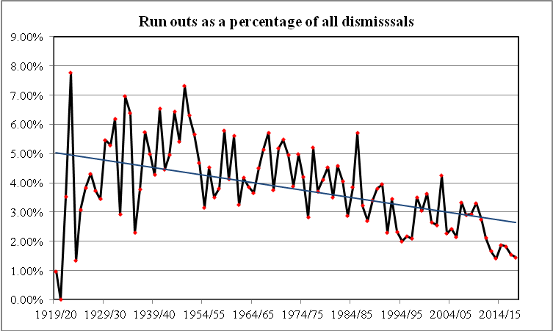

This graph shows the percentage of run out dismissals and quite clearly shows a significant decline from the high of

7.8% in 1922/23 to the low of 1.41% in 2013/14, ie 12 out of 851wickets to fall. The drop over the last seven years

is particularly noticeable with the percentage well below the 2% mark in the period.

**Graph 18**

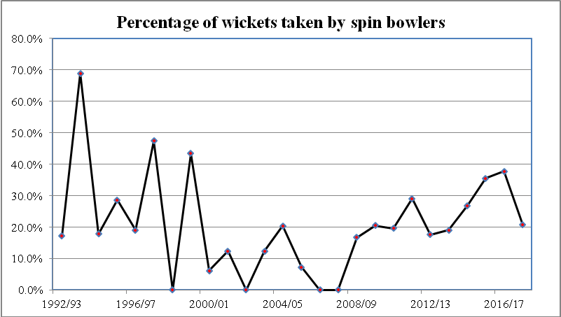

This graph shows the percentage of wickets taken by spin bowlers over the period of four day cricket.

There was a high of 68% in 1993/94 when only three bowlers took more than 20 wickets, two were spin bowlers

Priest and Goodson and the only medium pace bowler was Chris Flanagan. There was a decline of use and success

of spin bowlers until the 2009/10 season but since then there has become a greater awareness of their value and

over the last nine seasons the average has hover around the 25% mark.

**First Class, One Day and 20.20 Matches Played**

|  |  |  |  |  |  |  |  |
| --- | --- | --- | --- | --- | --- | --- | --- |
|  | **Matches** |  |  |  | **Days** |  |  |
|  | **FC** | **Min Overs** |  | **FC** | **50 Over** | **20.20** | **Total** |
| 1988/89 | 24 | 8,568 |  | 72 | 15 |  | 87 |
| 1989/90 | 30 | 10,710 |  | 90 | 18 |  | 108 |
| 1990/91 | 30 | 10,710 |  | 90 | 18 |  | 108 |
| 1991/92 | 30 | 10,080 |  | 90 | 18 |  | 108 |
| 1992/93 | 25 | 9,520 |  | 85 | 18 |  | 103 |
| 1993/94 | 18 | 8,064 |  | 72 | 34 |  | 106 |
| 1994/95 | 22 | 9,856 |  | 88 | 34 |  | 122 |
| 1995/96 | 16 | 7,168 |  | 64 | 34 |  | 98 |
| 1996/97 | 25 | 11,200 |  | 100 | 34 |  | 134 |
| 1997/98 | 16 | 7,168 |  | 64 | 34 |  | 98 |
| 1998/99 | 16 | 6,500 |  | 65 | 34 |  | 99 |
| 1999/00 | 16 | 6,500 |  | 65 | 34 |  | 99 |
| 2000/01 | 30 | 12,000 |  | 120 | 34 |  | 154 |
| 2001/02 | 30 | 12,000 |  | 120 | 32 |  | 152 |
| 2002/03 | 30 | 12,000 |  | 120 | 32 |  | 152 |
| 2003/04 | 25 | 10,000 |  | 101 | 32 |  | 133 |
| 2004/05 | 25 | 10,050 |  | 101 | 32 |  | 133 |
| 2005/06 | 25 | 10,050 |  | 101 | 32 | 7 | 140 |
| 2006/07 | 25 | 10,050 |  | 101 | 32 | 16 | 149 |
| 2007/08 | 25 | 10,500 |  | 101 | 32 | 16 | 149 |
| 2008/09 | 25 | 10,500 |  | 101 | 32 | 25 | 158 |
| 2009/10 | 30 | 12,000 |  | 120 | 27 | 31 | 178 |
| 2010/11 | 30 | 12,000 |  | 120 | 27 | 31 | 178 |
| 2011/12 | 30 | 11,640 |  | 120 | 27 | 31 | 178 |
| 2012/13 | 30 | 11,640 |  | 120 | 27 | 32 | 178 |
| 2013/14 | 30 | 11,640 |  | 120 | 27 | 32 | 179 |
| 2014/15 | 30 | 11,640 |  | 120 | 27 | 33 | 180 |
| 2015/16 | 30 | 11,520 |  | 120 | 27 | 33 | 180 |
| 2016/17 | 30 | 11,520 |  | 120 | 27 | 33 | 180 |
| 2017/18 | 30 | 11,520 |  | 120 | 27 | 33 | 180 |

The above table indicates the maximum and minimum numbers of days of cricket available since 1988/89 season.

**20 Wickets or more taken in season ????**

|  |  |  |  |
| --- | --- | --- | --- |
|  | **Spin bowlers** |  | **Other bowlers** |
| 1992/93 | 3 |  | 13 |
| 1993/94 | 3 |  | 6 |
| 1995/96 | 3 |  | 13 |
| 1996/97 | 2 |  | 6 |
| 1997/98 | 3 |  | 11 |
| 1998/99 | 6 |  | 14 |
| 1999/00 | 2 |  | 9 |
| 2000/01 | 5 |  | 9 |
| 2001/02 | 3 |  | 15 |
| 2002/03 | 2 |  | 21 |
| 2003/04 | 1 |  | 15 |
| 2004/05 | 3 |  | 15 |
| 2005/06 | 1 |  | 11 |
| 2006/07 | 0 |  | 8 |
| 2007/08 | 0 |  | 11 |
| 2008/09 | 2 |  | 11 |
| 2009/10 | 2 |  | 12 |
| 2010/11 | 3 |  | 15 |
| 2011/12 | 4 |  | 14 |
| 2012/13 | 3 |  | 15 |
| 2013/14 | 3 |  | 16 |
| 2014/15 | 4 |  | 21 |
| 2015/16 | 5 |  | 17 |
| 2016/17 | 4 |  | 14 |
| 2017/18 | 4 |  | 21 |
|  |  |  |  |

**Comparison of bowlers taking 20 wickets or more in a season**

**1992/93 eight 4 day matches + final 1993/94 five 4 day matches + 2 semi final + final**

Spin bowlers 2,970 balls 54 wkts s/r 55 Spin bowlers 2,826 balls 51 wkts s/r 55

Other bowlers 12,062 balls 259 wkts s/r 46 Other bowlers 975 balls 23 wkts s/r 42

Spin bowlers% **17.3%**  Spin bowlers% **68.9%**

**1994/95 seven 4 day matches + final 1995/96 five 4 day matches + final**

Spin bowlers 2,538 balls 44 wkts s/r 57 Spin bowlers 3,086 balls 48 wkts s/r 64

Other bowlers 9,622balls 203 wkts s/r 47 Other bowlers 5,828 balls 119 wkts s/r 49

Spin bowlers% **17.8%**  Spin bowlers% **28.7%**

**1996/97 eight 4 day matches + final 1997/98 five 4 day matches + final**

Spin bowlers 4,572 balls 75 wkts s/r 61 Spin bowlers 2,489 balls 47 wkts s/r 53

Other bowlers 14,459 balls 318 wkts s/r 45 Other bowlers 2,392 balls 52 wkts s/r 46

Spin bowlers% **19.1%**  Spin bowlers% **47.4%**

**1998/99 five 4 day matches + final 1999/00 five 4 day matches + final**

Spin bowlers 0 balls Spin bowlers 2,711 balls 57 wkts s/r 48

Other bowlers 3,826 balls 91 wkts s/r 42 Other bowlers 3,913 balls 74 wkts s/r 53

Spin bowlers% **0%**  Spin bowlers% **43.5%**

**2000/01 ten 4 day matches 2001/02 ten 4 day matches**

Spin bowlers 1,801 balls 24 wkts s/r 75 Spin bowlers 3,791 balls 54 wkts s/r 70

Other bowlers 18,696 balls 362 wkts s/r 52 Other bowlers 27,060 balls 541 wkts s/r 50

Spin bowlers% **6.2%**  Spin bowlers% **12.4%**

**2002/03 ten 4 day matches 2003/04 eight 4 day matches + final**

Spin bowlers 0 balls Spin bowlers 3,021 balls 43 wkts s/r 70

Other bowlers 23,110 balls 423 wkts s/r 55 Other bowlers 15,654 balls 304 wkts s/r 51

Spin bowlers% **0%**  Spin bowlers% **12.4%**

**2004/05 eight 4 day matches + final 2005/06 eight 4 day matches + final**

Spin bowlers 4,783 balls 81 wkts s/r 59 Spin bowlers 680 balls 21 wkts s/r 32

Other bowlers 15,540 balls 316 wkts s/r 49 Other bowlers 14,565 balls 267 wkts s/r 54

Spin bowlers% **20.4%**  Spin bowlers% **7.3%**

**2006/07 eight4 day matches + final 2007/08 eight 4 day matches + final**

Spin bowlers 0 balls Spin bowlers 0 balls

Other bowlers 10,562 balls 220 wkts s/r 48 Other bowlers 14,567 balls 290 wkts s/r 50

Spin bowlers% **0%** Spin bowlers% **0%**

**2008/09 eight 4 day matches + final 2009/10 ten 4 day matches**

Spin bowlers 3,573 balls 49 wkts s/r 73 Spin bowlers 4,098 balls 49 wkts s/r 83

Other bowlers 12,062 balls 244 wkts s/r 49 Other bowlers 15,147 balls 289 wkts s/r 52

Spin bowlers% **16.7%** Spin bowlers% **20.5%**

**2010/11 ten 4 day matches 2011/12 ten 4 day matches**

Spin bowlers 4,847 balls 83 wkts s/r 58 Spin bowlers 7,823 balls 118 wkts s/r 66

Other bowlers 17,304 balls 340 wkts s/r 51 Other bowlers 14,523 balls 287 wkts s/r 51

Spin bowlers% **19.6%** Spin bowlers% **29.1%**

**2012/013 ten 4 day matches 2013/14 ten 4 day matches**

Spin bowlers 5,148 balls 74 wkts s/r 70 Spin bowlers 5,991 balls 82 wkts s/r 73

Other bowlers 17,015 balls 345 wkts s/r 49 Other bowlers 19,963 balls 346 wkts s/r 58

Spin bowlers% **17.6%** Spin bowlers% **19.1%**

**2014/15 ten 4 day matches 2015/16 ten 4 day matches**

Spin bowlers 6,692 balls 188 wkts s/r 36 Spin bowlers 8,988 balls 171 wkts s/r 53

Other bowlers 27,563 balls 509 wkts s/r 54 Other bowlers 18,332 balls 308 wkts s/r 60

Spin bowlers% **26.9%** Spin bowlers% **35.6%**

**2016/17 ten 4 day matches 2017/18 ten 4 day matches**

Spin bowlers 8,368 balls 158 wkts s/r 53 Spin bowlers 6,665 balls 132 wkts s/r 50

Other bowlers 13,284 balls 259 wkts s/r 51 Other bowlers 22,071 balls 506 wkts s/r 44

Spin bowlers% **37.8**%Spin bowlers% **20.7**%

When making the comparison over the last 26 years with spin bowlers and other types of bowlers who have taken more than

20 wickets in a season, it shows that the spinners have bowled 97,461 balls and their 1,703 wickets is 19% of the total wickets

taken. The strike rate is 57.

The fast and medium paced bowlers have bowled 370,095 balls and taken their 7,295 wickets at a strike rate of 51.

There has been a marked increase in the use and success of spin bowlers over the past ten years to the point in the 2016/17

season where four of the top five wicket takers were spinners. Patel 44 wickets, Nethula 43 wickets, Sodhi 40 wickets,

Kuggeleijn 34 wickets and Astle 31 wickets.

But in 2017/18 although AY Patel was the leading wicket taker with 48 wickets the overall percentage at 20% had

dropped significantly. The other spin bowlers were JS Patel with 36 wickets, IS Sodhi 28 wickets and MD Craig 20 wickets.

Looking only at the last five seasons the percentage of wickets taken by the spin bowlers rises to 27.5% which is certainly

in line with the International trend of greater use and success and the strike rate of 50.2 is only slightly less than the fast,

medium pace bowlers at 52.5

Points penalties for slow over rates have effected four provinces, Wellington (1992/93, 1994/95, 1995/96),

Auckland (1993/94, 1996/97,1997/98), Otago (1996/97,1997/98) Central Districts (1997/98) but since 1998/99 only monetary

fines have been in place.

**Outrights Under or Over 336 Overs**

|  |  |  |  |  |
| --- | --- | --- | --- | --- |
| Year | Under | Over | Total | % Under to Total |
| 1992/93 | 6 | 3 | 9 | 66.67% |
| 1993/94 | 6 | 7 | 13 | 46.15% |
| 1994/95 | 9 | 8 | 17 | 52.94% |
| 1995/96 | 6 | 7 | 13 | 46.15% |
| 1996/97 | 12 | 9 | 21 | 57.14% |
| 1997/98 | 14 | 1 | 15 | 93.33% |
| 1998/99 | 7 | 3 | 10 | 70.00% |
| 1999/00 | 7 | 6 | 13 | 53.85% |
| 2000/01 | 13 | 4 | 17 | 76.47% |
| 2001/02 | 18 | 5 | 23 | 78.26% |
| 2002/03 | 7 | 12 | 19 | 36.84% |
| 2003/04 | 8 | 1 | 9 | 88.89% |
| 2004/05 | 12 | 7 | 19 | 63.16% |
| 2005/06 | 9 | 5 | 14 | 64.29% |
| 2006/07 | 6 | 7 | 13 | 46.15% |
| 2007/08 | 10 | 3 | 13 | 76.92% |
| 2008/09 | 7 | 6 | 13 | 53.85% |
| 2009/10 | 11 | 10 | 21 | 52.38% |
| 2010/11 | 11 | 6 | 17 | 64.71% |
| 2011/12 | 15 | 2 | 17 | 88.24% |
| 2012/13 | 15 | 8 | 23 | 65.22% |
| 2013/14 | 7 | 9 | 16 | 43.75% |
| 2014/15 | 12 | 13 | 25 | 48.00% |
| 2015/16 | 13 | 8 | 21 | 61.90% |
| 2016/17 | 8 | 8 | 16 | 50.00% |
| 2017/18 | 19 | 4 | 23 | 82.60% |
| **Total** | **268** | **162** | **430** | **62.32%** |

The question arises what percentage of matches have lasted into the fourth day. Taking 336 overs as the standard,

being the minimum required to be bowled when the competition was played over three days, the following figures

indicate that out of a total of 430 outrights achieved playing 4 day cricket, 268 could have been completed within

three days ie 61%. Twelve of the last fourteen years indicate a trend to early finishes with the 2002/03 season

reversing that trend most emphatically.

**Comparison 3 day v 4 day first class cricket**

From 1981/82 to 1991/92 (11 years) 279 three day matches were played and from 2005/06 to 2016/17 (11 years)

338 four day matches have been played.

|  |  |  |  |  |  |  |  |  |  |  |  |
| --- | --- | --- | --- | --- | --- | --- | --- | --- | --- | --- | --- |
|  |  |  | **Ratio to** |  | **Ratio to** | **Runs/** | **Wickets/** | **Runs/** | **% Ratio 300** | **% ratio 100** | **% Decln** |
|  | **Mats** | **Outrights** | **Matches** | **Centuries** | **Balls** | **Over** | **Balls Bld** | **wickets** | **to Innings** | **to innings** | **to Inns** |
| 3 day | 279 | 157 | 56.27% | 301 | 1632 | 2.84 | 62.45 | 29.58 | 21.63% | 2/.14% | 31.42% |
| 4 day | 338 | 210 | 62.58% | 593 | 1056 | 3.29 | 62.40 | 34.28 | 41.02% | 1.40% | 20.10% |

Note that four day cricket produces more outrights, more centuries, a higher run rate, more runs to wickets lost

and more scores over 300. There are fewer declarations while the ratio to wickets lost remains the same.

The interesting statistic to note is the high number of declarations made during the period of 3 day cricket

but with fewer outright results achieved.

**Yearly comparison from 1996/97**

The chart below summarises the trend in first class cricket and clearly indicates how batsmen are beginning to dominate

the first class game.

|  |  |  |  |  |  |  |  |  |  |  |  |  |  |
| --- | --- | --- | --- | --- | --- | --- | --- | --- | --- | --- | --- | --- | --- |
| **Summary** | **Matches** | **Results** | **Results%** | **Inns** | **r/o** | **300+** | **300%** | **100-** | **wkt** | **r/wkt** | **Century** | **100/balls** | **LBW%** |
| 1996/97 | 24 | 21 | 87.50% | 82 | 2.82 | 25 | 30.49% | 3 | 767 | 27.63 | 24 | 1876 | 18.64% |
| 1997/98 | 16 | 15 | 93.75% | 55 | 2.89 | 14 | 25.45% | 0 | 456 | 28.65 | 15 | 1806 | 19.30% |
| 1998/99 | 16 | 10 | 62.50% | 49 | 2.84 | 13 | 26.53% | 2 | 395 | 30.81 | 19 | 1355 | 17.47% |
| 1999/00 | 16 | 13 | 81.25% | 58 | 2.78 | 16 | 27.59% | 2 | 523 | 28.17 | 18 | 1767 | 21.22% |
| 2000/01 | 30 | 17 | 56.67% | 104 | 2.85 | 30 | 28.85% | 3 | 866 | 31.12 | 39 | 1456 | 18.71% |
| 2001/02 | 30 | 23 | 76.67% | 108 | 2.77 | 26 | 24.07% | 5 | 940 | 26.36 | 33 | 1628 | 22.87% |
| 2002/03 | 30 | 19 | 63.33% | 99 | 2.75 | 26 | 26.26% | 1 | 825 | 30.92 | 36 | 1545 | 18.55% |
| 2003/04 | 25 | 9 | 36.00% | 81 | 2.88 | 25 | 30.86% | 1 | 706 | 28.98 | 24 | 1774 | 20.11% |
| 2004/05 | 25 | 19 | 76.00% | 88 | 2.99 | 24 | 27.27% | 1 | 784 | 29.30 | 34 | 1355 | 20.79% |
| 2005/06 | 25 | 14 | 56.00% | 89 | 3.09 | 30 | 33.71% | 1 | 742 | 31.77 | 29 | 1576 | 18.73% |
| 2006/07 | 25 | 13 | 52.00% | 90 | 3.18 | 37 | 41.11% | 1 | 690 | 37.37 | 53 | 917 | 19.13% |
| 2007/08 | 25 | 13 | 52.00% | 87 | 3.07 | 40 | 45.98% | 3 | 723 | 32.57 | 37 | 1242 | 13.69% |
| 2008/09 | 25 | 13 | 52.00% | 85 | 3.21 | 38 | 44.71% | 0 | 718 | 36.53 | 62 | 791 | 17.27% |
| 2009/10 | 30 | 22 | 73.33% | 108 | 3.38 | 50 | 46.30% | 2 | 878 | 37.60 | 66 | 887 | 14.12% |
| 2010/11 | 30 | 17 | 58.62% | 100 | 3.19 | 34 | 34.00% | 2 | 834 | 32.48 | 36 | 1416 | 17.03% |
| 2011/12 | 30 | 17 | 58.62% | 98 | 3.27 | 39 | 39.80% | 3 | 854 | 32.88 | 50 | 1031 | 16.98% |
| 2012/13 | 30 | 23 | 76.66% | 113 | 3.51 | 49 | 43.36% | 0 | 963 | 34.39 | 62 | 913 | 16.30% |
| 2103/14 | 30 | 16 | 53.33% | 105 | 3.35 | 50 | 47.62% | 1 | 851 | 36.44 | 52 | 1067 | 16.78% |
| 2014/15 | 30 | 25 | 83.33% | 113 | 3.34 | 45 | 39.82% | 0 | 958 | 32.69 | 43 | 1307 | 14.72% |
| 2015/16 | 30 | 21 | 70.00% | 116 | 3.49 | 50 | 43.10% | 2 | 989 | 33.88 | 50 | 1154 | 15.77% |
| 2016/17 | 30 | 16 | 57.14% | 110 | 3.34 | 36 | 32.73% | 2 | 838 | 33.16 | 54 | 943 | 16.83% |
| 2017/18 | 30 | 23 | 76.66% | 109 | 3.25 | 32 | 29.36% | 4 | 965 | 27.44 | 29 | 1683 | 15.03% |
| **Total** | **582** | **379** | **65.12%** | **2047** | **3.13** | **729** | **34.04%** | **39** | **17265** | **31.99** | **864** | **1266** | **17.56** |

**Number Of Players Used In First Class Cricket**

|  |  |  |  |  |  |  |  |
| --- | --- | --- | --- | --- | --- | --- | --- |
| 1984/85 | **107** | 1985/86 | **101** | 1986/87 | **92** | 1987/88 | **110** |
| 1988/89 | **100** | 1989/90 | **107** | 1990/91 | **110** | 1991/92 | **115** |
| 1992/93 | **106** | 1993/94 | **116** | 1994/95 | **118** | 1995/96 | **94** |
| 1996/97 | **119** | 1997/98 | **104** | 1998/99 | **111** | 1999/00 | **104** |
| 2000/01 | **110** | 2001/02 | **107** | 2002/03 | **112** | 2003/04 | **108** |
| 2004/05 | **110** | 2005/06 | **109** | 2006/07 | **116** | 2007/08 | **108** |
| 2008/09 | **116** | 2009/10 | **124** | 2010/11 | **122** | 2011/12 | **122** |
| 2012/13 | **122** | 2013/14 | **113** | 2014/15 | **114** | 2015/16 | **128** |
| 2016/17 | **116** | 2017/18 | **127** |  |  |  |  |

The increased number of first class matches in 2009/10 saw a rise in the number of players used to a new high. Four

day cricket averages 110 players each season and three day averages 105 players, the difference reflecting how the

increase in International cricket has affected the composition of provincial teams and annectoably there would seem to have

been an increase in the number of bowling injuries.

The one positive to emerge from the years of four day cricket has been the number of outright results obtained with a

reduced need for declarations. But with so many outrights (62%) finishing within 336 overs the question arises has the

increased availability of cricket been put to good advantage, has the cricket played been of better quality, has it helped the

players more easily bridge the step up to International cricket, has it encouraged greater use of spin bowlers, have the

players enjoyed the game more, have spectators shown greater interest, has the competition been more interesting and

more closely fought, have the teams been of more equal strength.